PG Department of Commerce
Experiential Learning
Workshops
- Workshop on ‘Paving Way towards Success with Unique Personality Traits’ conducted on August 17, 2022. RichaSodhi, Senior Sales Executive, Nestle India, Mumbai was the Resource Person.207 students were benefitted by this workshop.

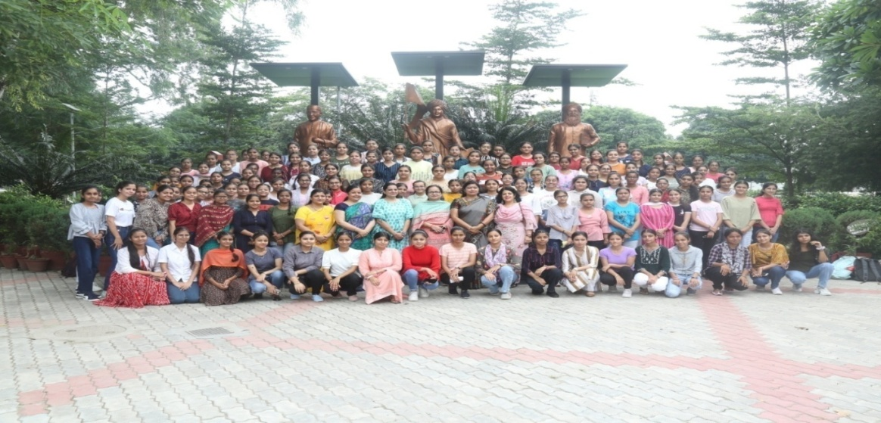

- Workshop on Banking practices organised on August 18, 2022.
Ms. DaljeetKaur, Manager, Punjab National Bank was the resource person.Total 32 students were benefited from the same.

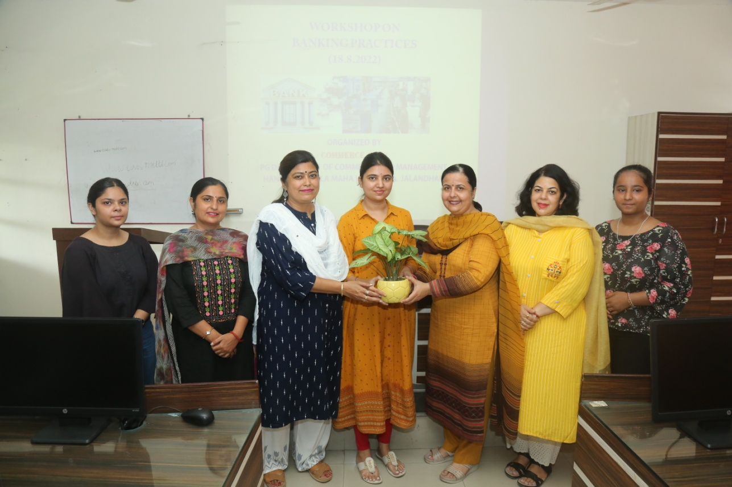

- Workshop on Banking Software ‘Finacle’ was organized on 30 November, 2022

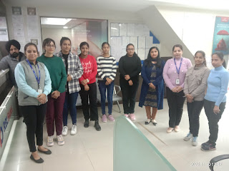

Seminars:
- ICSSR sponsored National Seminar on “Fostering Sustainable Investment Behaviour : A Paradigm Shift towards Green Economics Growth” organize on February 25,2023

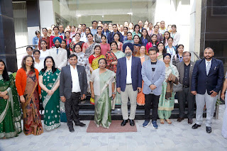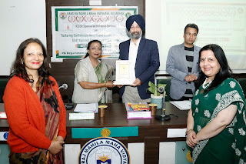

- Seminar on 'Deciphering Sustainability Skills in Banking, Finance & Insurance Sector' organised on August 27, 2022.
Mr. Kanwaljit Singh, Lead Trainer CPBFI was the Resource Person. This Seminar was conducted in collaboration with the Bajaj Finserv Limited.
185 students were benefited by deliberations of the resource person
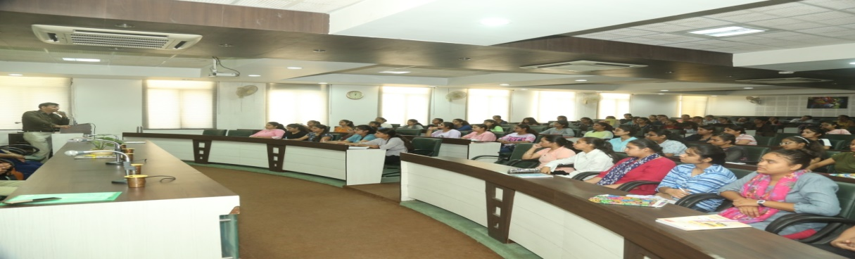

- Seminar on “Emerging Opportunities for Commerce Students in the field of CS” Organized on 17th August 2022
The key speakers for the day were CS Kanuba Jain (Ex Chairperson Jalandhar chapter of NIRC of ICSI) and CS SaurabhAggarwal (Chairperson Jalandhar chapter of NIRC of ICSI).Around 200 students attended the seminar and got their doubts cleared regarding CS course.
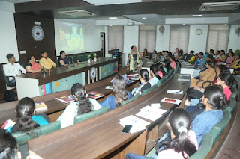

- Seminar on “Wakeup The Entrepreneur In You: A Mission for Self Reliance” organised on June 29,2023:

The Resource Persons for Seminar were Mr. Kashmiri Lal, CA Pankaj Jindal and Mr. Davinder Singh. .250 students participated in the seminar.

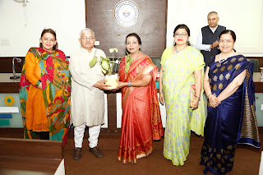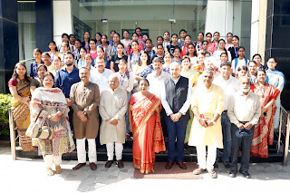

Guest Lectures :
- Series of Guest lectures on ‘On Line Trading Operations’ was organized. Mrs. Divya Nanda, Cluster Manager, RBL Bank, Model Town Branch, Jalandhar was the resource person.
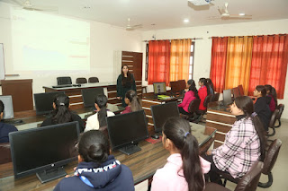
- Session on “Angel Investment/VC Funding” organized on 3.9.2022.

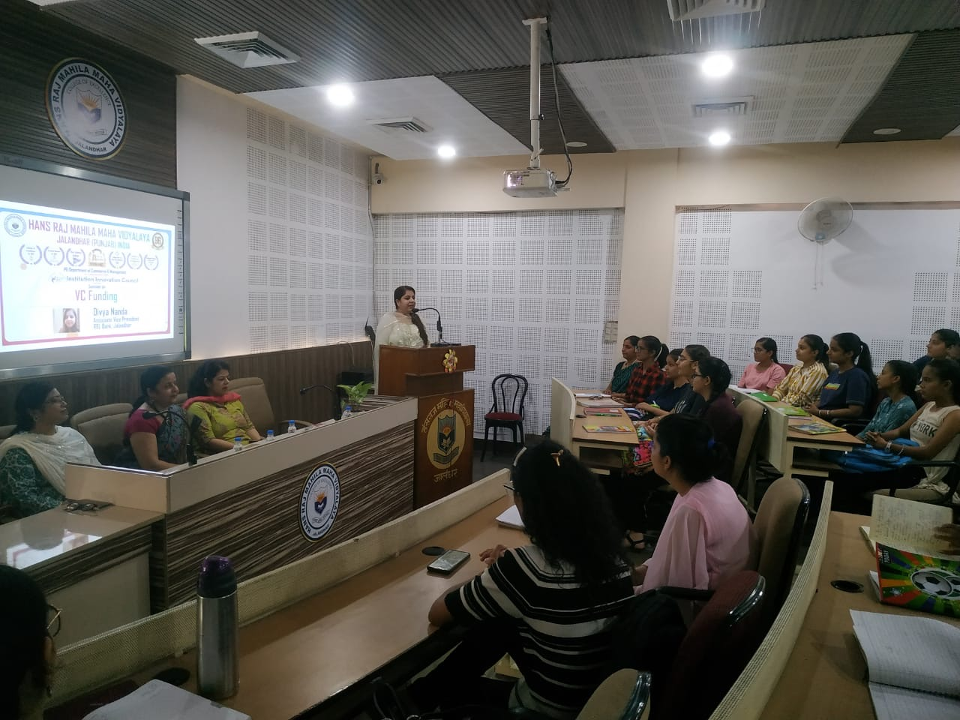

- Online Session on Business Model Canvas organized by PG Department of Commerce and Management in collaboration with Institution Innovation council on 6 September, 2022.
- 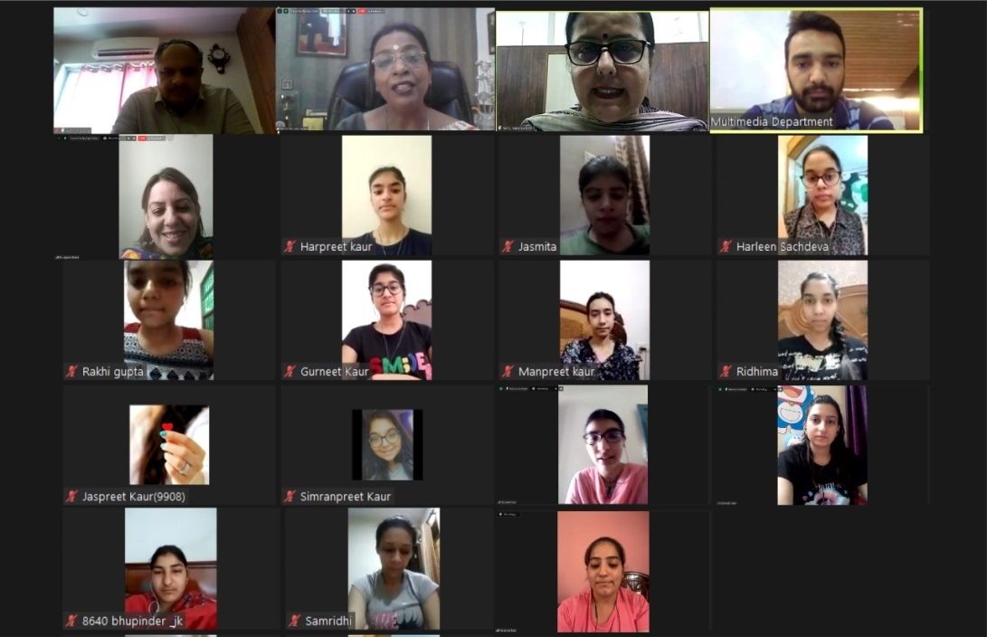

Visits :

Date | Industry
11-02-2023 | Industrial visit to BDM Industries, Shivambu International, Una, H.P.Total 100 students visited. | 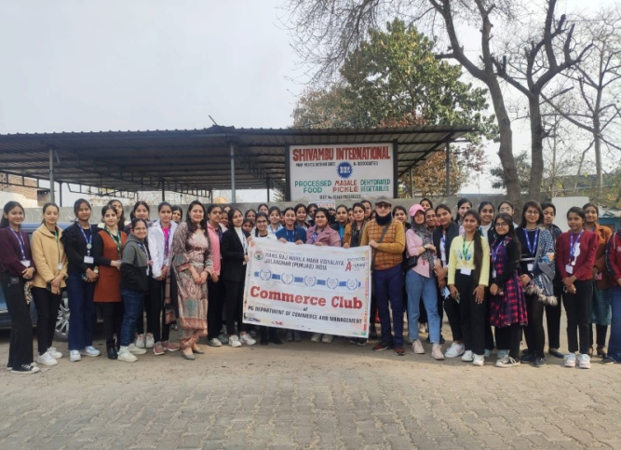
17-03-2023 | One day Education Visit cum Excursion tour to Punjab VidhanSabha, Chandigarh.  52 students visited. | 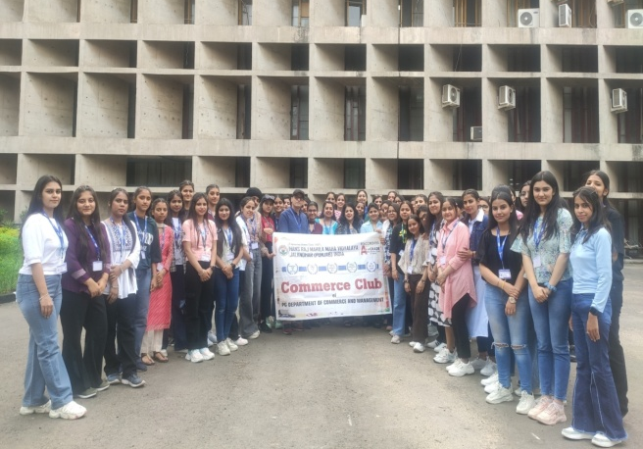
13-12-2022 | RBL Bank, Model Town Jalandhar

Trade fair :
- Fiesta- The Trade Fair was organized by the dept.
Date: 26 February 2023
No. of student participants: 37
Eleven students were awarded by the Principal as Budding Entrepreneurs.
S.No | Name | Class
1 | PrabhpreetKaur | B.Com Sem VI
2 | Komal | B.Sc. (IT) Sem IV
3 | Aakriti | B.A Sem VI
4 | ShivaniSaini | B.VocSem II
5 | AnchalDogra | B.Com Sem IV
6 | BhavyaBahree | BBA Sem IV
7 | Kris Sondhi | B.Com Sem II
8 | NandikaMehra | B.Voc (BFS) Sem VI
9 | Rasneet | BBA Sem VI
10 | Ritika | BCA Sem VI
11 | Ramanpreet | M.ScSem IV (Botany)

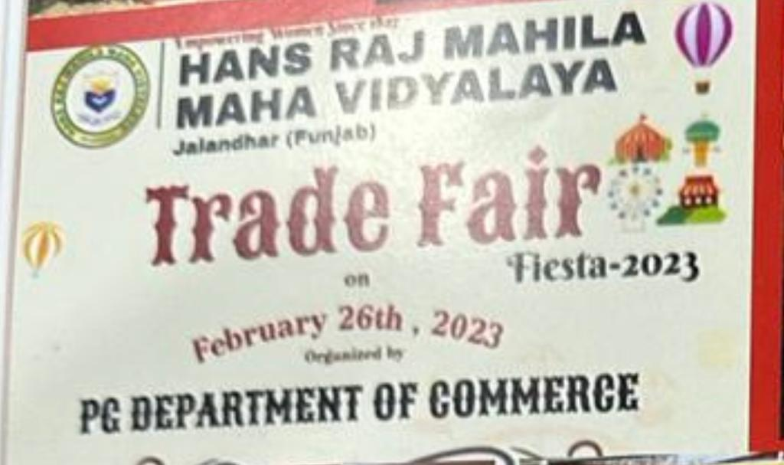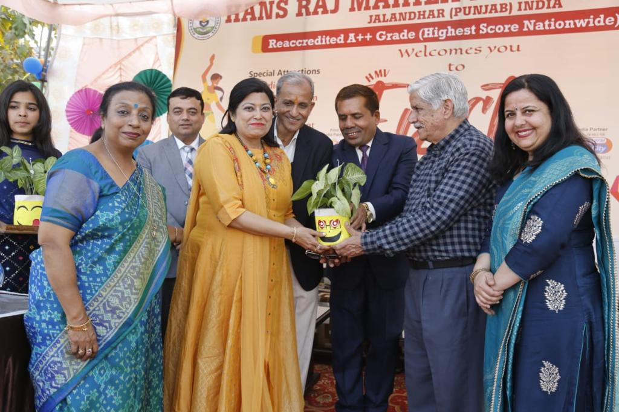

INTELLIGENCE HUNT 2022 ORGANISED
35 students participated in quiz. There were two rounds covering areas of entertainment , world , history, science and current affairs. 6 students were selected for mains out of 35 in the prelims round that consist of written test. SanjoliArora (M.com sem 3)stood first, ShainaSachdeva (M.com sem 3) stood second and MishthaKatyal( B.com sem 3) bagged 3rd position. The winners were presented with trophies.
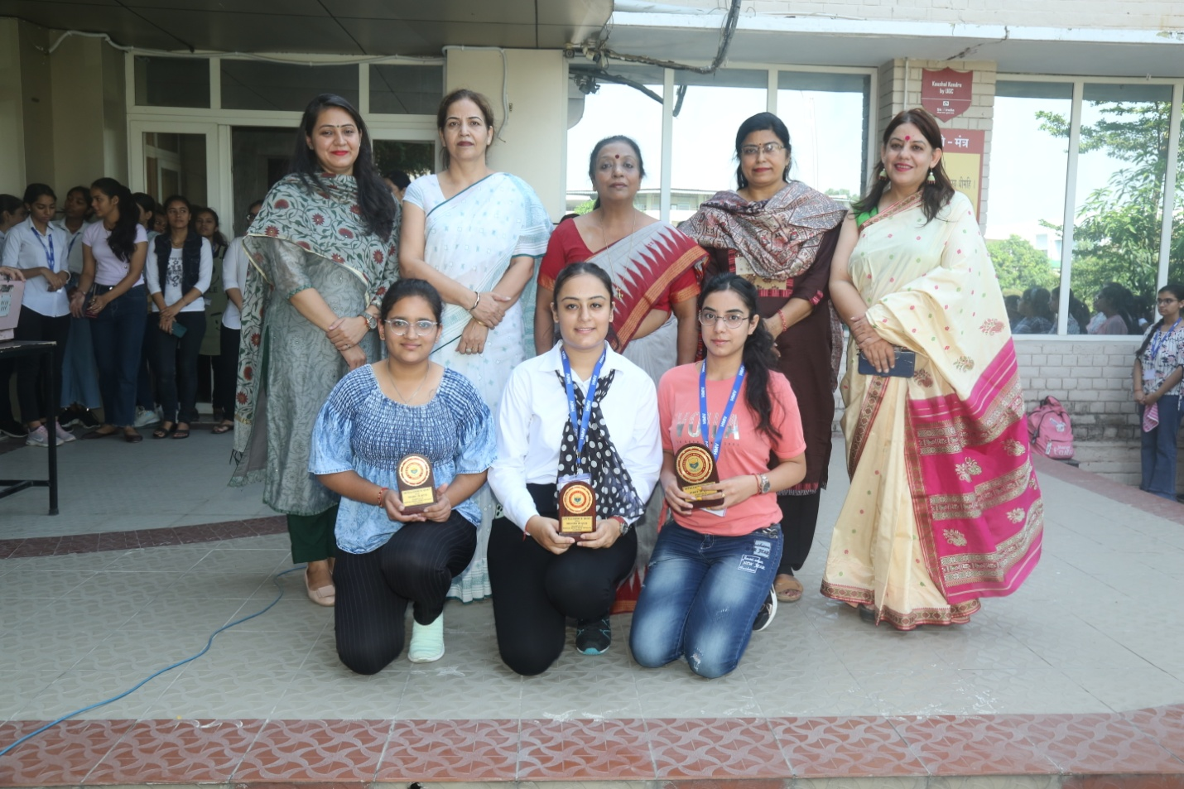

Students participate in various other events
- Event:Nukkadnatak on the theme “ Swachhta” under Unnat Bharat Abhiyan
Date November 14, 2022
Name of Participants
Anamikapandey B Com II
MehakShukla B Com II
Chanda B Com II
Neha B Com II
Sapna B Com II
RitikaChaudhary B Com II
Deepakshi B Com II
SimranVerma B Com I
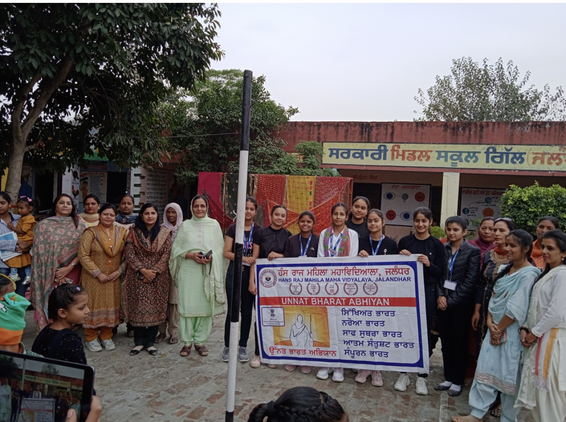
- Event : Medicinal Tree Plantation at Village Dhaliwal under Unnat Bharat Abhiyan
Date December 18, 2022
Name of Participants
AnamikaPandey B Com II
MehakShukla B Com II
Chanda B Com II
Neha B Com II
Sapna B Com II
RitikaChaudhary B Com II
Deepakshi B Com II
SimranVerma B Com II
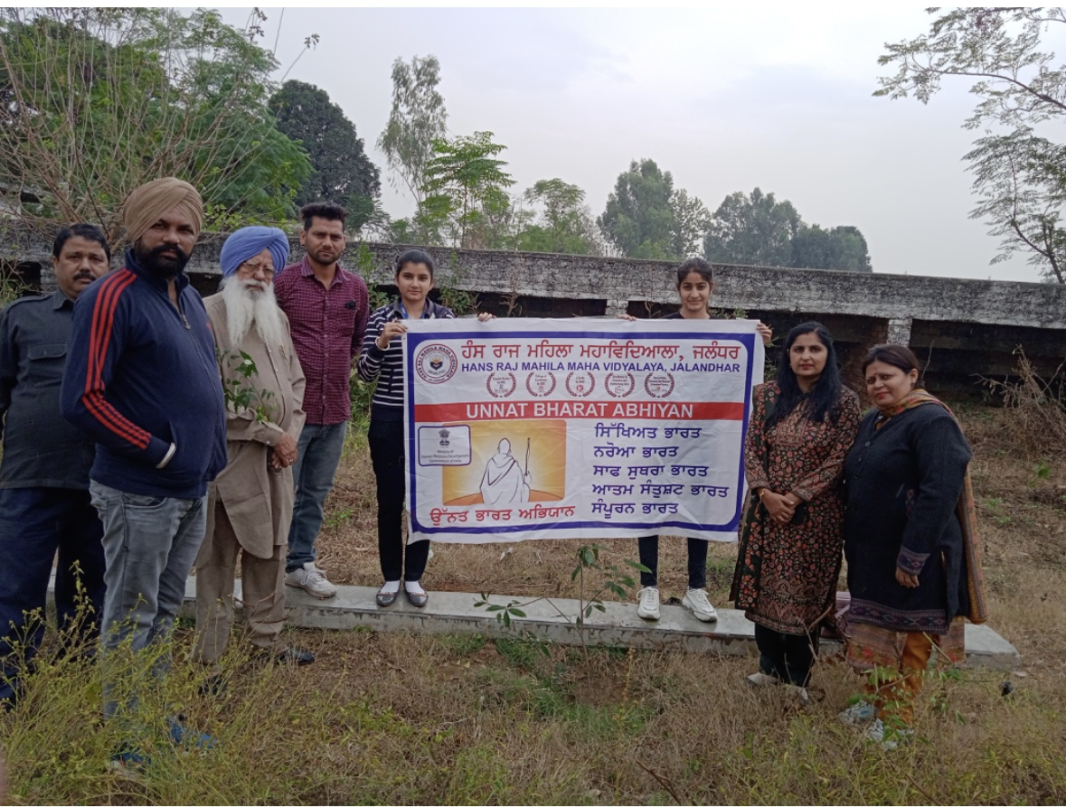
- Event : Children’s Day Celebration with students of Govt. School, Gillan Village under Unnat Bharat Abhiyan
Date November 15, 2022
Name of Participants
Anamikapandey B Com II
MehakShukla B Com II
Chanda B Com II
Neha B Com II
Sapna B Com II
RitikaChaudhary B Com II
Deepakshi B Com II
SimranVerma B Com II
